Graph Data Structure And Algorithms

A Graph is a non-linear data structure consisting of nodes and edges. The nodes are sometimes also referred to as vertices and the edges are lines or arcs that connect any two nodes in the graph.

*A Graph consists of a finite set of vertices(or nodes) and set of Edges which connect a pair of nodes.*

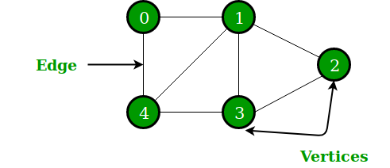

In the above Graph, the set of vertices V = {0,1,2,3,4} and the set of edges E = {01, 12, 23, 34, 04, 14, 13}.